Technical Documentation

E-commerce Analytics & Customer Lifetime Value Optimization

Project Title: Omni-channel Customer Analytics & Revenue Optimization for "Urban Cart" E-commerce.
Project Overview: Urban Cart is a mid-sized e-commerce retailer experiencing 25% YoY growth but facing declining customer retention (from 45% to 32% over 3 years). They need a comprehensive analytics solution to understand customer behaviour across web, mobile app, and physical stores.
The objective of this project is to build a comprehensive analytics solution to:
- Identify at-risk customers
- Improve marketing ROI
- Increase Customer Lifetime Value (CLV) by 15%
- Enable data-driven decision-making
The solution integrates structured and semi-structured data, builds a scalable data warehouse, applies predictive analytics models, and develops executive dashboards for strategic decision-making.
Technologies used:
- Database – PostgreSQL, MongoDB
- Programming - Python (ETL & Analytics)
- Data Warehouse - PostgreSQL
- Visualization - Microsoft Power BI

Business Problem Statement:
Urban Cart faces the following challenges:
- Declining retention rate
- Increasing customer acquisition cost
- Inefficient marketing spend allocation
- Lack of unified customer analytics system
The business requires a data-driven framework to understand customer behaviour and improve long-term revenue growth.

Project Objectives
The key objectives of this project were:
- Build an automated ETL pipeline
- Integrate data from PostgreSQL and MongoDB
- Design a scalable data warehouse using star schema
- Develop RFM-based customer segmentation
- Build CLV and churn prediction models
- Create interactive Power BI dashboards
- Provide actionable business recommendations

System Architecture:
Diagram:
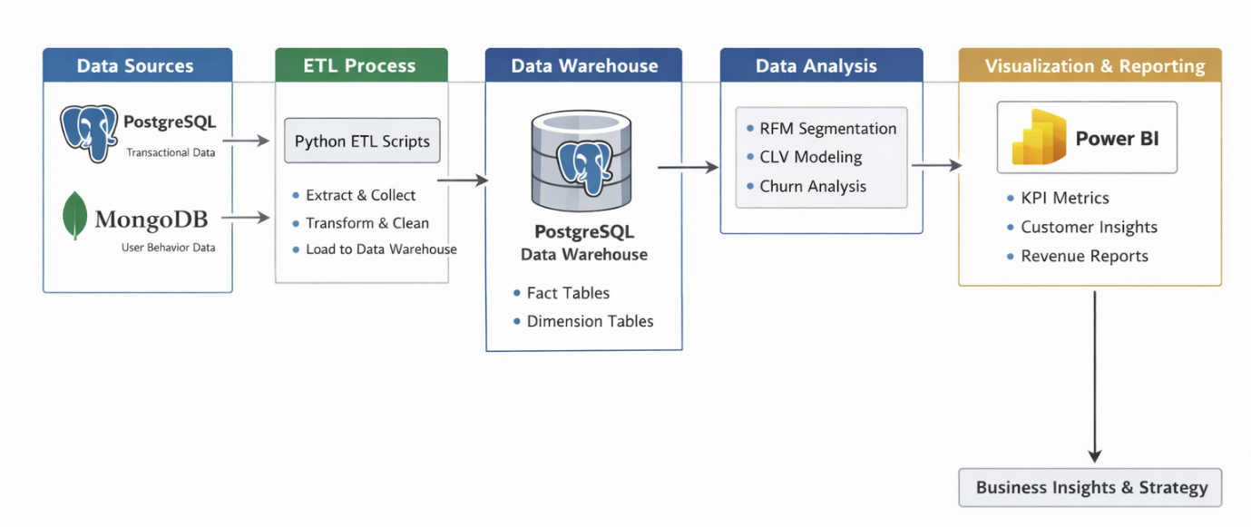
Data Flow Architecture
- Data Generated using ChatGPT (synthetic dataset)
- Stored in:
  - PostgreSQL (Transactional Data)
  - MongoDB (User Behaviour Logs)
- ETL Process using Python
- Data Loaded into PostgreSQL Data Warehouse
- Power BI Dashboard connected to PostgreSQL

Dataset Overview:
The dataset for Urban Cart analytics was collected from two primary systems:
- PostgreSQL (Transactional Data)
- MongoDB (Behavioural Data)

The dataset includes customers, orders, products, weblogs, and marketing campaigns data.
Tables: -
1. customers (customer_id, signup_date, demographics)
2. orders (order_id, customer_id, order_date, amount, channel)
3. products (product_id, category, price, cost)
4. web_logs (session_id, customer_id, pages_viewed, time_spent)
5. marketing_campaigns (campaign_id, channel, spend, period)

Dataset Volume: -
Total Customers: 5,000
Total Orders: 25,000
Total Products: 500
Total Web Sessions: 30,000
Total Marketing Campaigns: 50

Data Sources: -
1. PostgreSQL (Structured Data)
Tables used:
- customers
- orders
- products
- Marketing campaigns
2. MongoDB (Semi-Structured Data)
Collection:
- weblogs

ETL Pipeline Design:
The ETL (Extract, Transform, Load) pipeline was developed using Python to integrate data from multiple sources and prepare it for analytical reporting.
The pipeline extracts data from:
- PostgreSQL (Transactional Data)
- MongoDB (Behavioural Logs)
The transformed data is loaded into:
- PostgreSQL Data Warehouse
The pipeline is designed for automation, incremental loading, and high data quality.
Diagram:
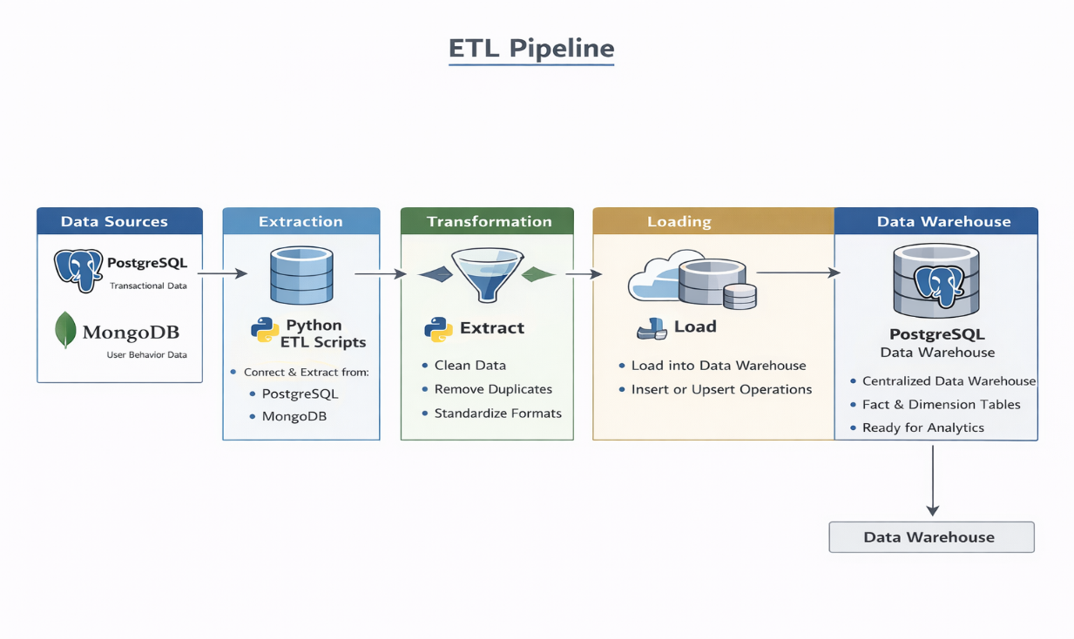

1.Extraction: -
PostgreSQL Extraction:
Data was extracted from PostgreSQL using optimized SQL queries to retrieve customer, order, product and marketing_campaigns records.
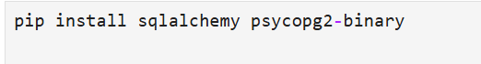

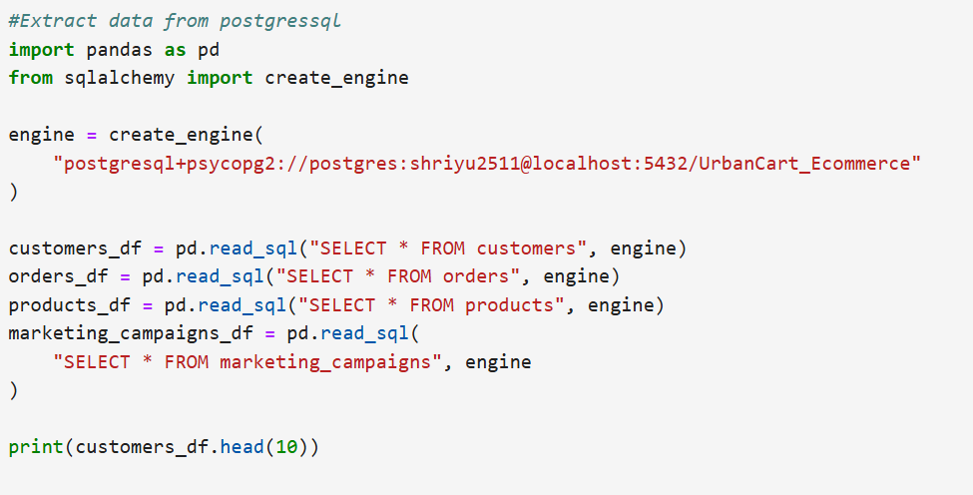

MongoDB Extraction: -
Web session data was extracted from MongoDB collections and flattened into structured tabular format for further processing.

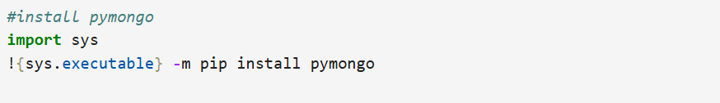

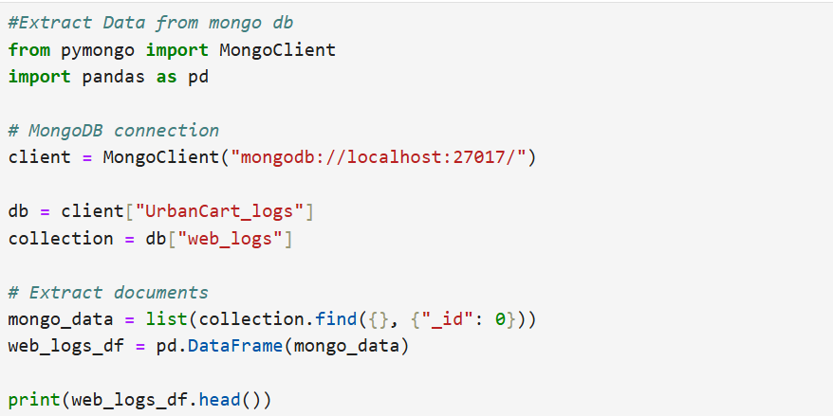

2. Transformation: -
The transformation phase was implemented using Python (pandas) to clean, standardize, enrich, and prepare the extracted data for analytical processing and warehouse loading.
This stage ensured data accuracy, consistency, and readiness for advanced analytics.
- Removed duplicate records from customer and order datasets
- Handled missing values using appropriate strategies:
- Dropped critical null rows
- Imputed non-critical fields where applicable
- Removed invalid transactions (e.g., negative or zero amounts)
- Corrected inconsistent date formats
- Ensured consistent data types (integer, float, datetime)

3.Load:-
Cleaned and transformed datasets were loaded into PostgreSQL using incremental loading logic based on timestamp columns to ensure efficient updates.
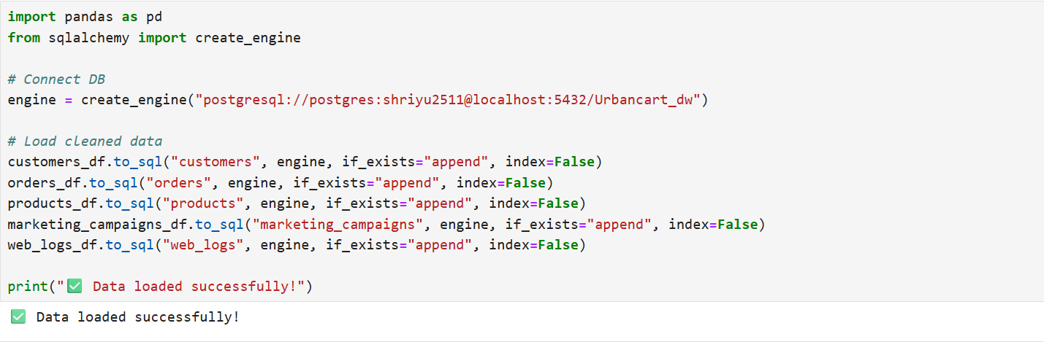

Data Warehouse Design: -
1.Design Star Schema: -
A Star Schema data model was implemented in the PostgreSQL data warehouse to support high-performance analytical queries and business intelligence reporting.
The schema consists of one central fact table connected to multiple dimension tables, forming a star-like structure.
Schema Structure:-
Fact Table:
- fact_orders
Dimension Tables:
- dim_customers
- dim_products
- dim_date
- dim_campaign

Diagram:
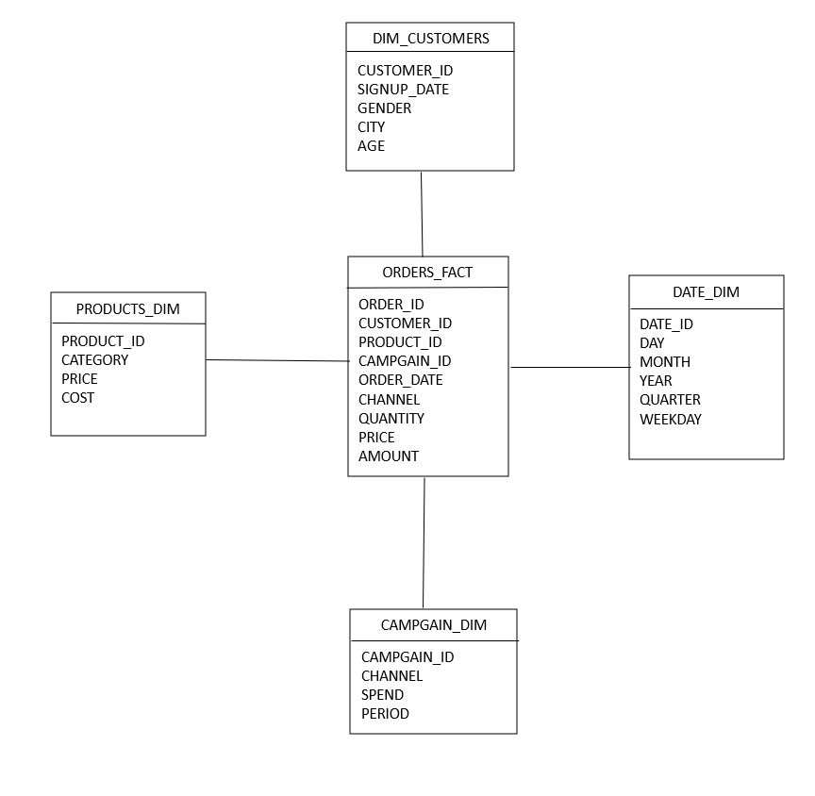

2.Incremental Data Loading: -
Incremental data loading is a strategy where only new or modified records are processed and loaded into the data warehouse instead of reloading the entire dataset.
This approach improves performance, reduces computational cost, and ensures efficient data refresh cycles.

3.Data Quality Checks: -
To ensure data integrity, reliability, and analytical accuracy, a comprehensive data quality validation framework was implemented using structured SQL scripts in PostgreSQL.
- Null validation
- Duplicate detection
- Revenue reconciliation
- Referential integrity checks

SQL Analytics Implementation: -
The SQL analytics layer was implemented in PostgreSQL to enable advanced customer intelligence, profitability analysis, marketing performance tracking, and cross-selling insights.
This layer transforms structured warehouse data into business-ready analytical outputs.

1.Customer 360° view :-
A unified Customer 360° View was created to integrate customer profile, transactional data, engagement metrics, and marketing interactions into a single analytical dataset.
The view combines :
- Purchase History
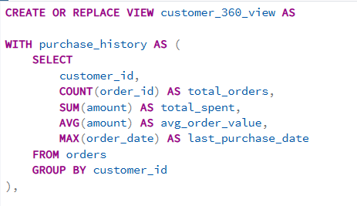
- Engagement Metrices
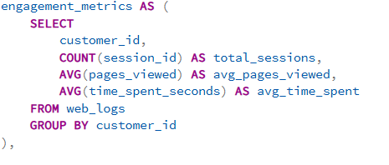
- Campaign responses
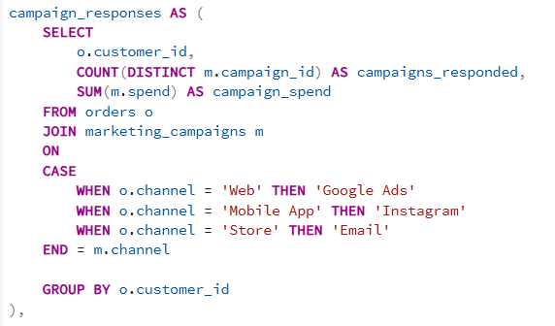

- Cohort Analysis
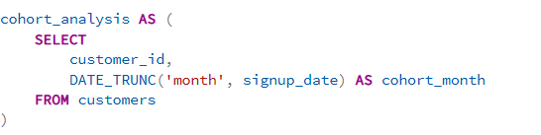
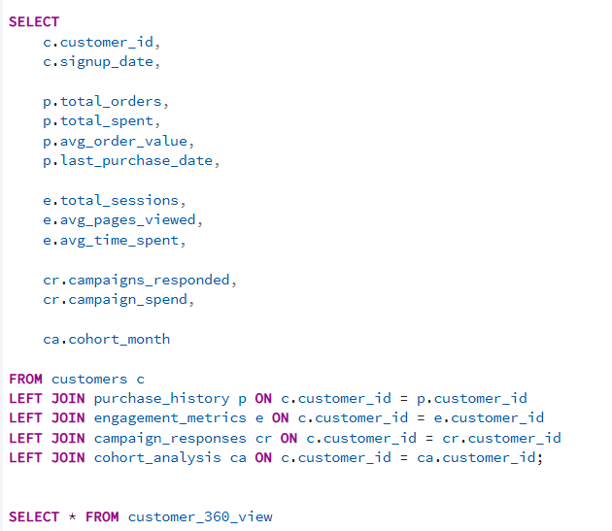

It provides a complete lifecycle understanding of each customer across all channels.
2.SQL Queries:-
- Customer churn probability
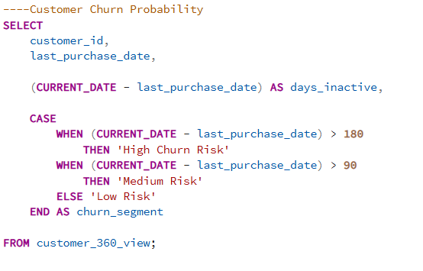
- Most profitable customer segments
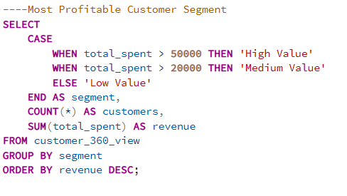
- Cross-selling opportunities
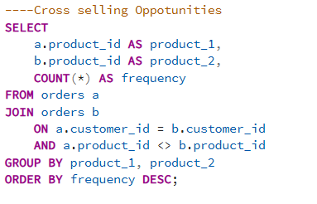
- Marketing ROI by channel
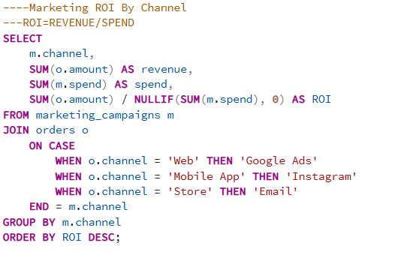

Advance Analytics: -
RFM Segmentation: -
RFM Analysis is a customer segmentation technique used in marketing and analytics to identify valuable customers based on purchasing behaviour.
Customer segmentation is a data analysis technique used to divide customers into meaningful groups based on their purchasing behaviour. In this project, RFM analysis (Recency, Frequency, Monetary) is used to identify high-value customers, loyal customers, and customers at risk of churn.
RFM analysis helps businesses understand customer engagement and purchasing patterns, enabling more effective marketing strategies and personalized campaigns.
RFM Model Components: -
1. Recency (R)
Recency measures how recently a customer made a purchase.
- Customers who purchased recently are more likely to buy again.
- Lower recency values indicate higher engagement.
Recency = Current Date − Last Purchase Date
2. Frequency (F)
Frequency measures how often a customer makes purchases within a given period.
- Customers with higher purchase frequency are considered loyal customers.
- Indicates repeat buying behaviour.
Frequency = Total Number of Orders per Customer
3. Monetary Value (M)
Monetary value represents the total amount a customer spends.
- Customers who spend more contribute higher revenue.
- Used to identify high-value customers.
Monetary = Total Purchase Amount per Customer
RFM Scoring Method
Customers are assigned scores based on their Recency, Frequency, and Monetary values. Each metric is typically scored on a scale from 1 to 5, where:
- 5 = Best customer behaviour
- 1 = Lowest engagement

CLV Prediction: -
Customer Lifetime Value (CLV) Prediction Model is a predictive analytical model used to estimate the total revenue a customer is expected to generate for a business during their entire relationship with the company.
A Customer Lifetime Value (CLV) Prediction Model is a predictive analytics technique that estimates the future financial value of customers based on their historical purchasing behaviour.
Formula for calculate CLV: -
CLV=Average Order Value×Purchase Frequency×Customer Lifespan
Average Order Value = average money spent per order
Purchase Frequency = Number of purchase per year
Customer Lifespan = Duration of customer stays active
Steps to build CLV Prediction Model:
1.Check orders_fact data:
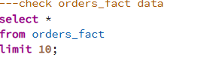
2.Calculate Basic Customer Metrices:
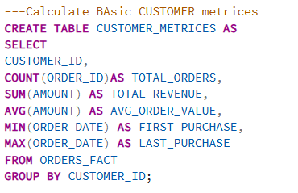
3.Calculate Customer Lifespan:
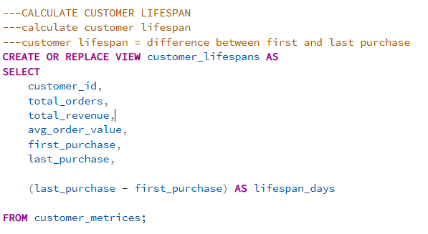
4.Calculate Purchase Frequency:
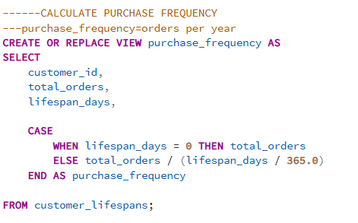
5.Calculate CLV:
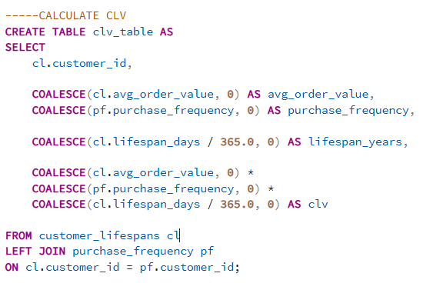

Association Rules: -
The goal of association rules is to discover relationships between products purchased in the same.
Identify frequently purchased product combinations in the UrbanCart dataset. By applying association rule mining, we can discover relationships between products and recommend items that customers are likely to purchase together.

Methods:
1.Generate product pairs: -
Products purchased by the same customer are paired together to identify co-occurrence patterns.
This step was implemented using a self-join on the orders table.
2.Calculate Product Frequency:-
The frequency of each product in the dataset is calculated to determine how often a product appears in orders.
Formula: -
Product Frequency = Number of times a product appears in orders
3.Calculate Support
Support measures how frequently a product pair appears in all transactions.
Formula:
Support = Pair Count / Total Orders
4.Calculate Confidence: -
Confidence measures the probability that Product B is purchased when Product A is purchased.
Formula:
Confidence = Pair Count / Product A Count
5.Calculate lift: -
Lift measures the strength of association between two products.
Formula:
Lift = Confidence / Support (Product B)
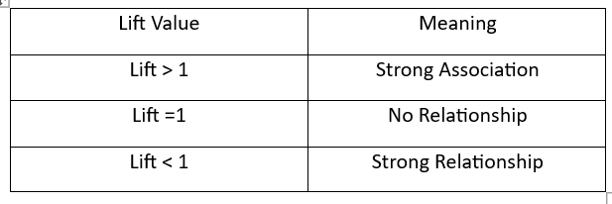
Cohort Analysis:-
Cohort analysis groups customers based on their first purchase month and tracks their behavior over time.
A cohort is a group of customers who share a common event in a specific time period.
Cohort analysis is to analyze customer retention behavior over time by grouping customers based on their first purchase month. This analysis helps identify patterns in repeat purchases and customer engagement.
The analysis was performed using the ORDERS_FACT table from the UrbanCart database.
The following tools were used for cohort analysis:
1.Python – Data Analysis
2.Pandas – Data Manipulation
3.Matplotlib - Visualization
4.Seaborn - Cohort heatmap visualization
5.PostgreSQL - Data storage
Methods: -
1.Data Preparation:
- The order date column was converted into datetime format to enable time-based operations.
- An additional column representing the order month was created.
2. Identify Customer Cohort:
- Each customer's first purchase month was identified and stored as the cohort month.
- The cohort month represents the month in which a customer made their first purchase.
3.Calculate Cohort Index:
- The cohort index represents the number of months since the customer's first purchase.
4.Create Cohort table:
- A cohort table was created to calculate the number of unique customers in each cohort period.
- The data was then transformed into a pivot table.
5. Calculate Retention Rate:
- Customer retention was calculated by dividing the number of returning customers by the total number of customers in the cohort.
- The retention matrix represents the percentage of customers returning in each subsequent month.
- Visualization:
- A cohort retention heatmap was generated to visualize customer retention patterns.
- The heatmap helps easily identify retention trends across cohorts.
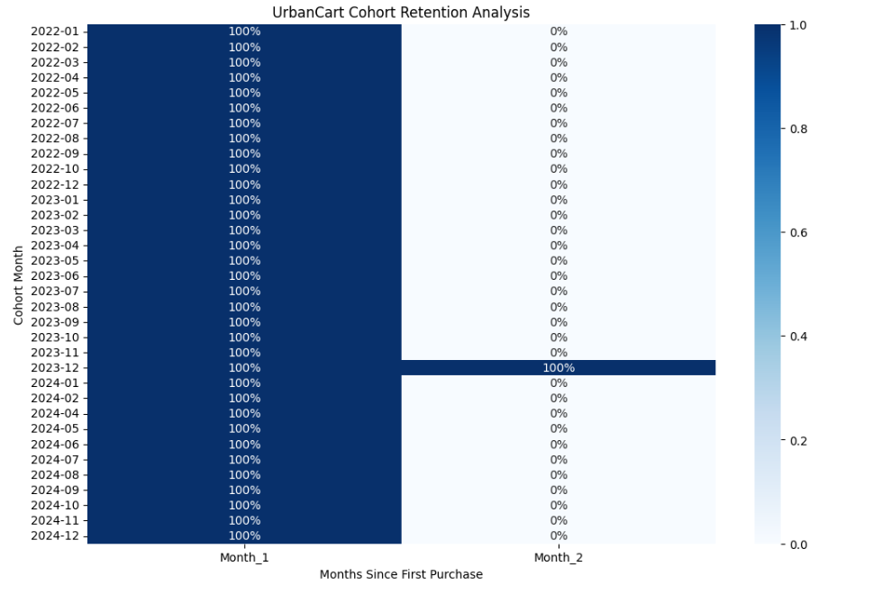

Power BI Dashboards: -
Overview:
After completing the data processing and analytics in PostgreSQL and Python, the final step of the Urban Cart analytics pipeline was to build an interactive Power BI dashboard.
The dashboard integrates business metrics such as MRR, CAC, CLV, RFM Segmentation, Cohort Retention, and Product Recommendations to support data-driven decision making.
The Power BI dashboard was developed to present key business insights derived from the Urban Cart analytics pipeline. The dashboard provides interactive visualizations to monitor sales performance, customer behaviour, and product trends.
Power BI was used to transform analytical outputs from Snowflake and Python models into meaningful visual reports.
The dashboard is divided into two major components:
1.KPI Overview
2.Interactive Reports
Data Source: -
The Power BI dashboard connects to the PostgreSQL Urban Cart database.
Data Connection: -
Power BI was connected to PostgreSQL using the PostgreSQL Connector for Power BI.
Steps performed:
- Open Power BI Desktop
- Select Get Data
- Choose PostgreSQL Connector
- Enter the following details:
- Snowflake Server URL
- Warehouse
- Database: URBANCART_DW
- Schema: PUBLIC
- Import required tables into Power BI.
KPI Overview: -
The KPI Overview section of the Power BI dashboard provides a high-level summary of key business metrics that help evaluate the overall performance of Urban Cart. These indicators allow management to quickly monitor revenue growth, customer acquisition efficiency, and customer retention patterns.
The KPIs displayed in the Power BI dashboard include
- Total Revenue: -
- Total revenue represents the sum of all transaction values.
- This metric indicates the total income generated by the platform
- Formula:
Total Revenue = Sum of all order amounts

- Total Orders: -
- Total Orders represent the total number of transactions made by customers.
- Formula:
Total Orders = Count of all orders

- Total Customers: -
- Total Customers represent the number of unique customers who placed orders.
- Formula:
Total Customers = Count of unique customer IDs

- Average Order Value (AOV):-
- Average Order Value measures the average amount spent by customers per order.
- Formula: -
Average Order Value = Total Revenue ÷ Total Orders

- Monthly Recurring Revenue (MRR):-
- Monthly Recurring Revenue represents the total revenue generated each month.
- Formula:
MRR = Total revenue generated in a month

- Customer Acquisition Cost (CAC):-
- Customer Acquisition Cost measures how much it costs to acquire a new customer.
- Formula:
CAC = Total marketing cost ÷ Number of new customers

- Customer Lifetime Value(CLV):-
- Customer Lifetime Value estimates the total revenue a customer generates during their relationship with the company.
- Formula:
CLV = Average Order Value × Purchase Frequency × Customer Lifespan
- Customer Retention Rate (CRR):-
- Retention Rate measures the percentage of customers who continue purchasing from the platform.
- Formula:
Retention Rate = (Number of returning customers ÷ Total customers) × 100
Interactive Dashboards: -
This section presents the Power BI dashboards developed as part of the project. These dashboards provide interactive visual insights into customer behaviour, revenue trends, churn risk, and marketing performance.
Each dashboard is designed to support data-driven decision-making.

1.Customer Analytics Executive Dashboard:-
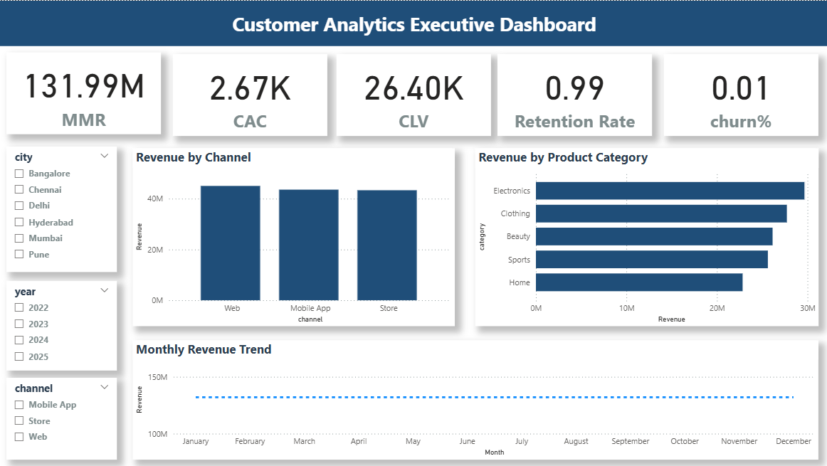
The Executive Dashboard provides a high-level overview of business performance.
Key Metrics:
- Monthly Recurring Revenue (MRR)
- Customer Acquisition Cost (CAC)
- Customer Lifetime Value (CLV)
- Retention Rate
- Churn Percentage
Insights:
- Helps stakeholders quickly assess overall business health
- Identifies trends in revenue and customer retention
2. Customer Segmentation Matrix (RFM Analysis) :-
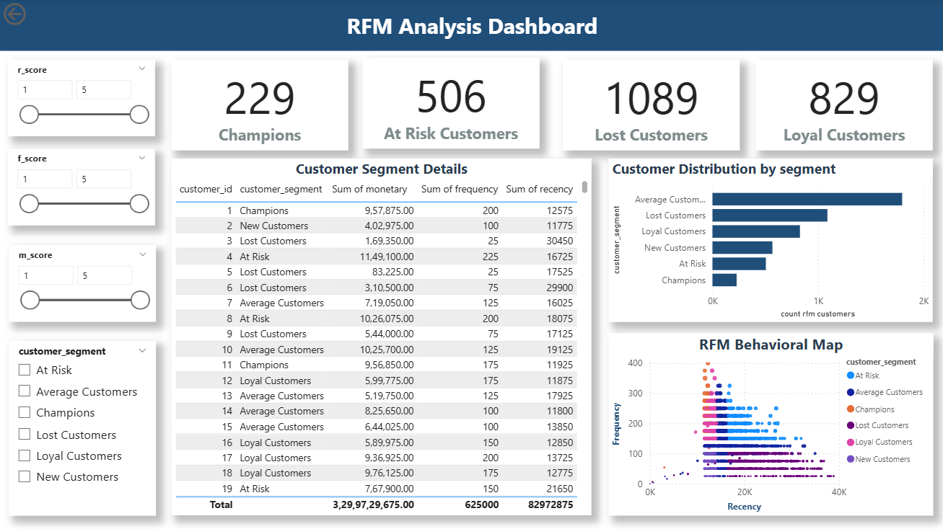
This dashboard segments customers based on Recency, Frequency, and Monetary value.
Key Segments:
- Champions
- Loyal Customers
- At Risk Customers
- Lost Customers
Insights:
- Enables targeted marketing campaigns
- Helps improve customer retention strategies

3.Churn Prediction Dashboard: -
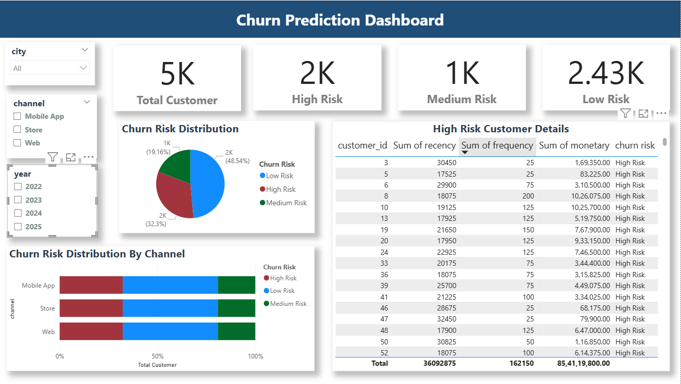
This dashboard focuses on identifying customers at risk of churn.
Key Features:
- Customer segmentation (High, Medium, Low Risk)
- Churn distribution visualization
- Detailed customer-level data
Insights:
- Helps identify high-risk customers
- Enables targeted retention strategies

4.Marketing Attribution Dashboard:-
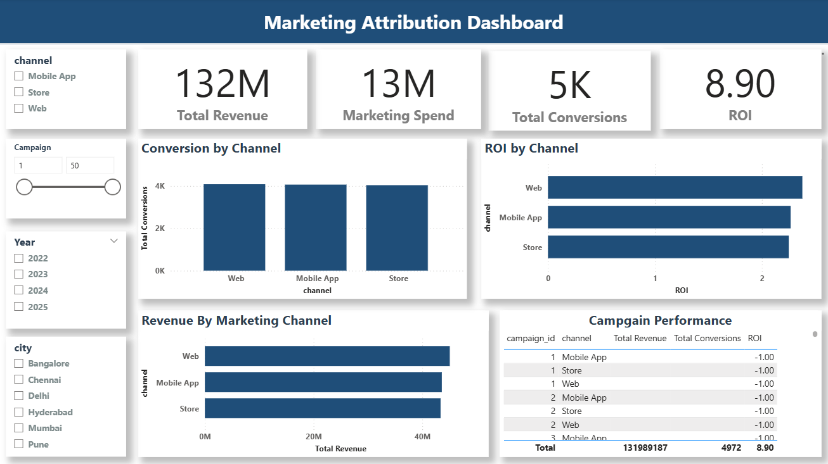
This dashboard analyse marketing performance across different channels.
Key Metrics:
- Total Revenue
- Marketing Spend
- Conversions
- Return on Investment (ROI)
Insights:
- Identifies most effective marketing channels
- Helps optimize marketing budget allocation

5.Product Recommendation Dashboard:-
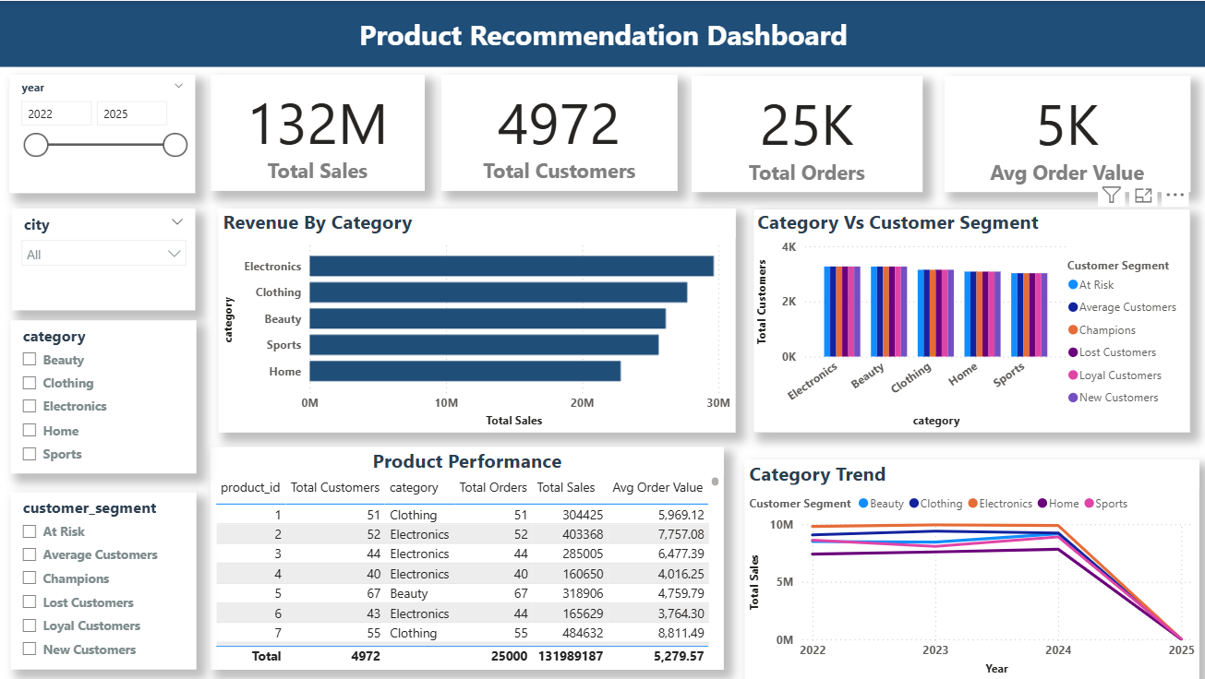
This dashboard provides insights into product performance and customer preferences.
Key Features:
- Revenue by product category
- Customer segmentation by category
- Product-level performance metrics
Insights:
- Helps identify top-performing products
- Supports cross-selling and upselling strategies

Business Recommendations: -
- Improve Customer Retention Strategy
- Target High-Value Customers
- Optimize Marketing Spend
- Reduce Early Customer Churn
- Implement Cross-Selling & Upselling
- Enhance Customer Personalization
- Improve Product Strategy

Conclusion: -
The Urban Cart project shows how data can be used to understand customer behaviour and improve business performance. By combining data from different sources, we were able to analyse customer activity, identify high-value customers, and detect customers who are likely to stop buying.
Using techniques like RFM analysis, CLV calculation, and churn analysis, the project provides useful insights that help the business make better decisions. The Power BI dashboards make it easy to track important metrics like revenue, customer growth, and marketing performance.
Overall, this project helps Urban Cart improve customer retention, increase revenue, and use marketing budget more effectively. It also shows how a data-driven approach can support business growth in e-commerce.

